**WenQiang Liu**

**Full-Stack Software developer**

* **Full Stack Software Developer:**

Spearhead end –to-end mobile web development using Laravel, Wordpress, Opencart, Wix, Codeignitor and React to build front-end architecture, back-end applications and user interface, using an iterative Scrum-based approach.

Drive performance turning, query plans, indexing, and table partitioning.

Write reusable unit test documents to ensure quality control and identify bugs

Culitivate familiarity with microservices through scalable system Spring build-out.

* **Front-end Developer**

Created exceptional UX design; determined back-end data display; designed styling, colors, and interface; incorporated best practices for technical SEO; and optimized website navigation.

Designed and edited templates for Angular framework, Laravel framework.

Create dynamic web pages using Javascript

Followed Scrum methodology for software workflow management and collaborated on APIs

* **Backend Developer**

Cultivated expertise with web applications to build out server-side functions

Wrote code using PHP on Laravel framework; leveraged familiarity with CSS and HTML to ensure seamless front-end content delivery.

Managed hosting environment, database administration, and application scaling

* **Language Skills:**

PHP, PHP Framework (Laravel, Codeignitor), Kotlin, Object-C, HTML5, CSS3, JS(JQuery, Node.js, Angular.js, Express.js, bootstrap, ReactJs, Vue), Python, XML, MySQL, MongoDB, Hybrid Language (ionic, react native)

* **SDK Skills:**

J2EE, Spring, JMF, Laravel, Joomla, Drupal, Zend, AngularJS, IOS SDK, Pods, Android-SDK, Android-NDK, COCOS2d-x & COCOS3d and Corona SDK, Paylpal SDK, Stripe SDK, Facebook SDK, Twitter SDK, XMPP SDK, BBM SDK, Java SDK, Credit Card SDK, In-app purchase SDK, Node.js, Express.js, phongap SDK, XMPP SDK, libjingle SDK, WebRTC, Ionic,Yelp SDK, etc

* **Tool Skills:**

NetBeans, Eclipse, Android Studio, Xcode, Dreamwaver, Editplus, photoshop, illustrator, Visual Studio Code, Git.

* **OS Skills:**

Mac OS, Linux(CentOS, Ubuntu, Fedora, RedHat)

* **Experienced Project Skills:**

<https://beacon-cloud.biz> : BBN Company Business System

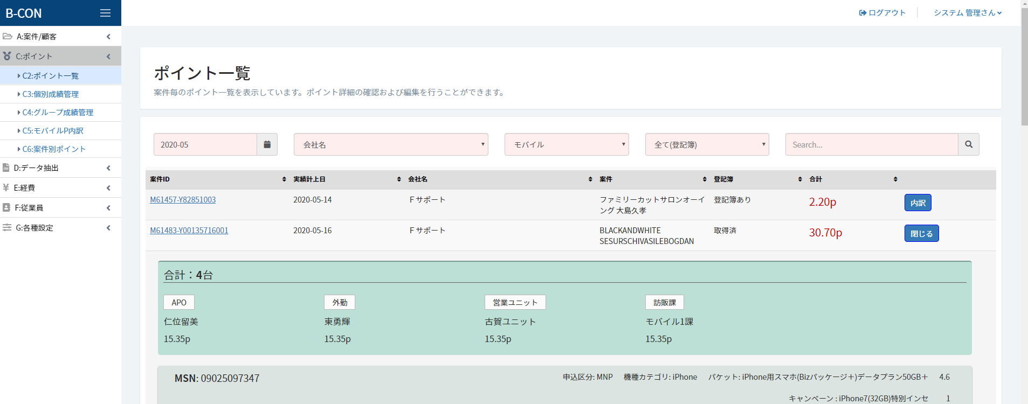

**Used skill: Laravel, Jquery, MYsql, aws ec2 instance, Mail, pusher integration.**

<http://hoya.com.my> : Online Lens Simulation responsive web site.

<http://ww.hakoren.com> : Online social food mobile & web site.

<https://www.esynchrony.com> : Online Dating web site & CMS

<https://www.stadiumastro.com> : Football game news and matches site.

<http://www.light-talk.com/en> : Lecture site using wordpress

https://www.innquest.com/roommaster-anywhere : hotel room reservation system

<http://unicablink.com> : Malaysia taxi booking CMS & API.

<http://www.belloinnovation.com> : bello innovation sdn bhd advertisement site

<http://hfn.com.my> : Online-shopping site

<http://agdabrands.com> : AGDA Brands sdn bhd introduction site

<http://hwtgroup.com.my> : HWT group introduction site

<http://www.rakuten.co.jp>

<http://shoppingfeed.jp>

<https://www.jigsawtrading.com> : Stock Marketing Site

<https://anyrateauto.com/> : Car repair Site

<http://homeworkstudy.net/> : Homework Site

<https://studyace.net/> : Homework Site

<https://www.mealsuite.com/> :

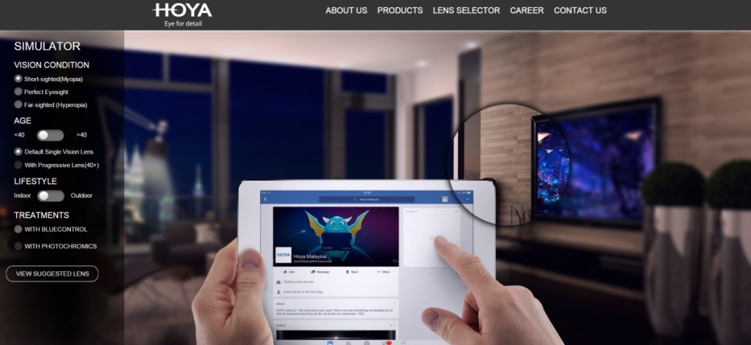

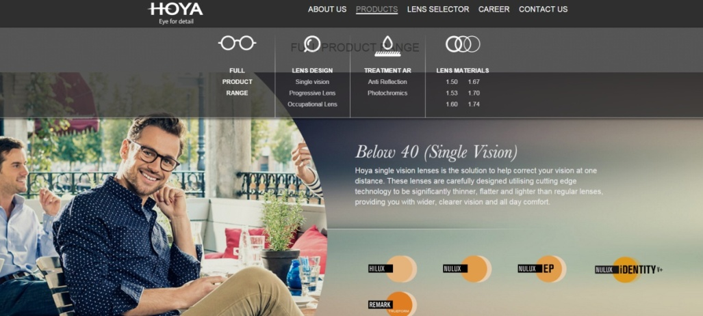

Used skills: lens simulator on web, HTML5, CSS3, Jquery, Kwicks.js, Jssor.js, canvas, iframe. fb integration. CMS

I have developed several web application such above as full stack developer.